Script for Real Estate Agent FinCEN Training
(1 Hour Class)

SLIDE 1: Welcome to this session on the FinCEN Residential Real Estate Rule. We hope that today’s conversation will ensure your closings with ____________________ (Insert Agency Name here) are smooth and seamless when the new requirements of the Residential Real Estate Rule become effective on December 1, 2025.
SLIDE 2: My name is ________________________________ (Insert name), and I am the _________________________ (Insert Title Here) with __________________ (Insert Company). Your title agency partner, ______________________________, thought it critical that you receive training on the new FinCEN Rule as it will impact many of your closings, and with your help as a key stakeholder in the process, we can keep issues to a minimum to ensure a successful closing for all your customers.
SLIDE 3: Today’s agenda will give you the basics of the New Rule and provide you with the knowledge you need to support your customers, both buyers and sellers on closings that are impacted. Some of you are already familiar with the FinCEN geographic targeting Orders no doubt. May I see a show of hands of those who have handled files impacted by the GTOs? So that experience is helpful, but a lot has changed under the New Rule.
Today in our brief time together we will learn who or what FinCEN is, what the New Rule requires from all the parties to the transaction if reportable under the New Rule. Then we will work through the roles of the various parties to the transaction and how that can work together for frictionless closing.
SLIDE 4: This is what the lawyers ask us to share. This is not legal advice but rather information for you and your customers. You should always seek guidance from your broker, agency manager or counsel for specific concerns and legal advice.
SLIDE 5: I want to offer a special thanks to the American Land Title Association, the title industry’s trade organization. They worked diligently for years to make sure the New Rule was not too onerous for the parties. They have prepared much of this presentation to educate key stakeholders in the real estate industry and continue to monitor this New Rule through its effective date and final implementation. You will no doubt shortly be using the Buyer and Seller Data Collection forms they have prepared for our industry to ensure ease of use and uniformity.
SLIDE 6: So let’s get started and dive into the new FinCEN Residential Real Estate Rule which will become effective on December 1, 2025. It will impact all residential cash closings with an entity or trust purchaser occurring on or after that date, so we need to be prepared early. Your title agent partner, here at __________________________ (Insert Agency Name) is working to deploy systems and processes to be fully compliant and also support you in making sure the deal gets closed.
SLIDE 7: I have been discussing FinCEN and I do not want to assume anything today. What is FinCEN? FinCEN is the acronym for the Financial Crimes Enforcement Network, part of the U.S. Treasury Department. It is an agency created by the U.S. Congress with a very clear and critical mission:
“…to safeguard the financial system from illicit use, combat money laundering and its related crimes including terrorism, and promote national security through the strategic use of financial authorities and the collection, analysis, and dissemination of financial intelligence.”
The New Residential Real Estate Rule was developed to directly support that mission.
SLIDE 8: So let’s start to probe the new Residential Real Estate Rule.
SLIDE 9: Contained in the Federal Register at 31 CFR Chapter X, the New Rule spells out Anti-Money Laundering Regulations for Residential Real Estate Transfers. The New Rule requires the reporting of details regarding residential cash transactions to entities (LLCs, partnerships or corporations and trusts) to FinCEN. It also requires reporting on transactions involving hard money and private lenders which includes Seller financing or even loans to family members.
SLIDE 10: And what is the purpose of the RRER – Plain and simple, to STOP CRIME. You have no doubt been part of a transaction involving fraudsters and money launderers, but FinCEN is going after even bigger fish in this pursuit.
SLIDE 11: FinCEN and other federal and international law enforcement agencies have confirmed that money-laundering occurs in residential transactions that helps:
Terrorists, Drug Lords, Oligarchs, and Criminal Conspirators. Entities and Trusts identification data in land records simply do not disclose who is the “Beneficial Owner” (the person who controls the money) behind these legal entities unless a separate report is made. FinCEN wants to know the individual’s name because then they are able to correlate to other data they have collected on wrongdoers to stop money-laundering. If they keep this pressure on these criminals, perhaps money-launderers quit using the residential real estate market to launder their ill-gotten gains and we can get back to simply helping folks realize their true American Dream.

Earlier, some of you raised your hand that you had dealt with the FinCEN GTOs. Those were essentially a pilot for this final rule program. Those GTOs were successful so the program was expanded and now we have the New Rule that impacts every US state, territory and residential cash sale to entities or trust, regardless of the purchase price.

SLIDE 12: A critical reason we needed the New Rule is that the U.S. was far behind the rest of the world in combatting money laundering by terrorists, oligarchs and other criminal actors.

The Financial Action Task Force (FATF) is the global money laundering and terrorist watchdog agency. It sets international standards for targeting illicit funds linked to drug trafficking, illicit arms trade, cyber fraud and other serious financial crimes.

If you watch any crime dramas you are familiar with Interpol, which is the International Police Organization which facilitates international police cooperation and criminal investigations. It is focused on cross border investigations related to cyber crime and money laundering. You can see how critical it is to have that cross-border cooperation in today’s highly mobile world.

I said that the GTO’s were a successful pilot program. In fact the data supports that:

SLIDE 12: So the Pilot Program works. And it pays for itself, a very unusual metric in today’s fiscal scrutiny. Just look at the numbers:
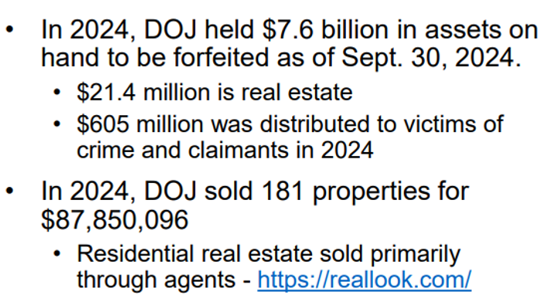
And look at this map. It is happening all across the country. When they clamp down in one area, criminals simply move to a new location, so the New Rule shuts that down as it will be enforced across all US jurisdictions.

SLIDE 14: The Treasury Department is seizing assets from bad doers and recouping that money for the innocent victims as well as to continue crime fighting.

SLIDE 15: Here are a few examples to show you how these criminals operate and how this New Rule can thwart their crimes. First example involved a foreign oligarch and his US attorney.
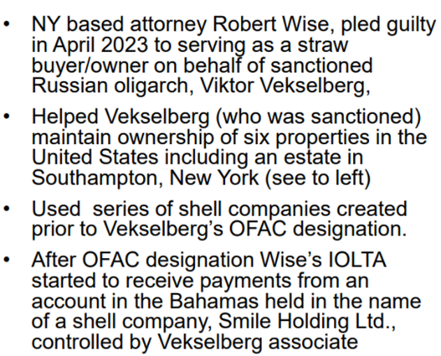

SLIDE 16: The Vekselberg house was a palace but look at this modest home. Well below this façade was a huge drug manufacturing operating.
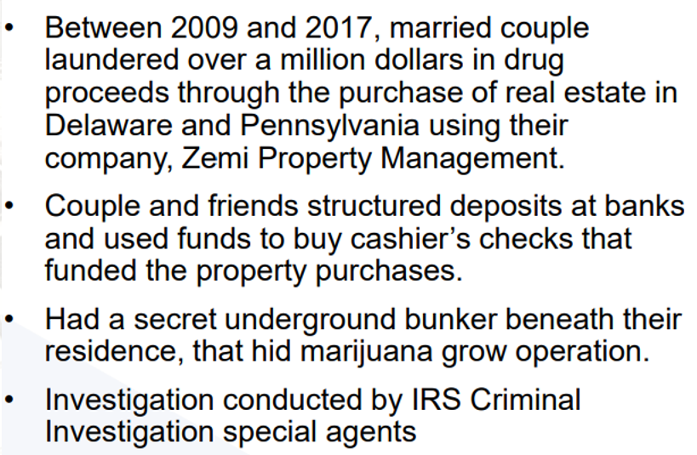

SLIDE 17: Then to me the most egregious crime. Corrupt foreign leaders are usurping moneys that should go to their constituents and countrymen only to line their own pockets.
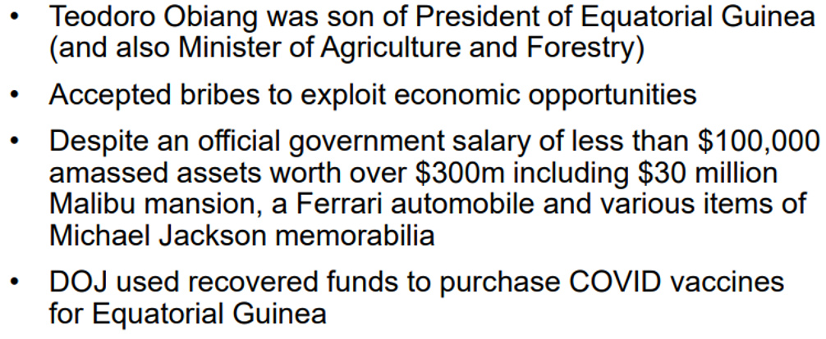
These are the criminals that FinCEN wants to stop. It does impact a lot of honest homebuyers, but the result benefits all of us.

SLIDE 18: Now let’s dive into the actual New Rule and what information your Buyers and Sellers will be required to provide to the title agent. Again, only impact is to cash, non-financed transactions where an entity or trust is purchasing a one to four family home. Traditionally financed transactions with an institutional lender who has an anti-money laundering program are totally exempt.
SLIDE 19: What information will need to be collected under the New Rule?
There are four main categories of data to be collected:
1. Buyer – Entity/Trust Details and Identification of the Beneficial Owners including address, SSN, and/or Passport Number
2. Seller – Individual’s Information or if an entity or trust, information about the entity or trust and Beneficial Owner Information
3. Property Details
4. Banking Information for Buyers including Source of Funds
This last category is new and will require a good deal of information that the title agent does not have access to. We will be asking our real estate partners to assist with this information.

Don’t distress, ALTA has developed standardized Buyer and Seller Data Collection Forms for use by your customers in assembling the data. We have provided copies of those forms for you so you can help your customers work through the data collection process, all with an eye toward smooth and speedy closings.

SLIDE 20: How will it affect my closing? Well hopefully it will not cause any issues. Early outreach by you and your title agent will insure customers are informed and there are no last minute surprises. That is key. Start collecting information early in the settlement process.

SLIDE 21:
Typically, Buyers and Sellers will have to submit information to the title agency before closing can be scheduled using a process your title agent partner will explain as part of their order intake process. Starting early will make sure there are no delays.

Your title agent will collect the data is a secure manner, likely through a secure online portal, a fillable form delivered to customers electronically, or a request for the data through a secure and encrypted email. Please encourage customers to follow the title agent’s guidance as we want to keep their information safe.

This process will require Buyers and Sellers to certify the accuracy of the information in writing to the title agent’s internal FinCEN expert and closer. That certification is on the ALTA Data Collection forms which the parties will sign. All the required information has to be delivered in advance of closing.

FinCEN has not prohibited charging customers for the data collection and reporting process which can be very time-consuming. Customer cooperation will keep those charges down. [Ask Agent, what or how they will charge their customers for this expense].

After closing, your job is done and your the title agency will be responsible for the mandatory reporting to FinCEN and the secure retention of the information for the statutory required period, 5 years.

SLIDE 22: Will the contact or closing documents be impacted by the New Rule?
The ALTA Data Collection Requests will be delivered to your customers at time of Order Entry so they can start collection information. Your title agent will be asking Buyer and Seller to execute standard Buyer and Seller Data Collection forms. Please encourage your customers to comply early in the order process. These forms were developed by ALTA so will be standard at all title agents’ offices and will guide them through the process

What about your forms? The Florida Bar, FREC and your local Boards of Realtors® are currently considering changes to the standard Purchase and Sale Agreement language to account for the New Rule so all Realtors® know the transaction could or will require FinCEN reporting.

Note: If your deal starts as an individual cash purchase and then the buyer wants to take title in their trust or in an LLC, alert the title agent as soon as possible. This will avoid last minute delays.

SLIDE 23: Back to the original GTOs. You may be familiar if the GTOs impacted any of your states or counties. Here in Florida __________(Insert state) the counties of Miami-Dade, Broward, Palm Beach, Hillsborough, Pasco, Pinellas, Manatee, Sarasota, Charlotte, Lee, and Collier counties(________________Insert impacted counties.) The New Rule will impact every county in the state.

SLIDE 24: For those of you familiar with the GTOs, I thought a comparison between the GTOs and the New Rule would be helpful to your understanding. You can see the critical items on the chart now on the screen:

1. Residential Property, 1 to 4 family homes. Include condos, co-ops, vacant land intended to be developed as residential property. Broader than GTOs as it also includes properties with mixed commercial and residential use, if the sale includes the transfer of a residential unit.

2. Geographic Impact, The GTOs impacted 9 states and various counties within those states. The New Rule impacts all US state and territories and all counties with in those states.

3. Threshold Dollar Amount – The GTOS in mopst counties started on transfers of $300,000 or more, with the exception of Baltimore county and city which started at $50,000. The New Rule has no threshold amount. Even zero-dollar transfer are reported. So if your customer says, I will buy in my name and then do a Quit Claims Deed to my LLC. Remember that the deed to the LLC is a reportable transaction so who ever prepares and records that deed will need to collect the data to report to FinCEN. So be careful counseling your Buyers on how to take title to try and avoid the New Rule. It is not avoidable.

4. Entities Impacted – GTOS looked at LLCs, Corporations and partnerships. The New Rule includes those and has added Trusts.

5. Parties Reporting. Under the GTO it was the buyer entity that had to report. Under the New Rule both the Buyer and Seller have reporting obligations. IN addition, financial information about the deal is now also reportable. Where do all the money come from to buy this property?

6. Criminal and Civil Penalties – Well those have not changed. Both those sanctions are available to prosecutors for non-compliance.

7. Will there be a charge? Under the GTO there was no charge and many title agents could pass the obligation to their underwriter. That is no longer available so your title agent may charge a small fee fore this process which involves several hours of work collecting the data and reporting it to FinCEN. In addition they must secure the data on a secure server which is an expensive proposition.

In Florida/ ______________ (Insert State here), the cost for FinCEN reporting should be part of the closing and settlement fee, not a separate charge. Check with your title agent on what will be charged so there is no surprise at closing.

(Title Agent may explain their charging practices here).

SLIDE 27: More on the cost of this work so you understand the impact to your title agent.

SLIDE 28: Why are title agents charging for this? This slide shows data collected by FinCEN from title professionals on the cost of training and deploying the New Rule. As you can see it is a lot of time and energy, and title industry professionals think these estimates are very conservative based on their experience.

Find out how the fee will be charged, is it a Buyer expense, a Seller expense, a charge to both? We have seen that most title agents will place charge on the Buyer since the purchase in an entity is what triggers the additional time and expense of FinCEN reporting.

SLIDE 29: Do we really have to comply – YES, unless you and your customer want to face the consequences.

SLIDE 30: As noted on the slide there are both criminal and civil penalties which are quite onerous particularly if there is willful non-compliance. That would be when title agent explains what needs to occur and what data needs to be collected, and your parties refuse.

SLIDE 31: I like to think positively and with a successful resolution in mind. So how can we ensure a smooth closing for all the parties?

SLIDE 32: Here are the key steps to ensure your transaction, though subject to the New FinCEN Rule reporting obligations, will proceed smoothly:

1. Ask your Buyers at time of contracting if they will be acquiring title in either an Entity or a Trust
2. Provide that information to your title agent at Order Entry
3. If a Buyer changes their mind, tell title agent ASAP so Closing is not delayed
4. If your Buyer or Seller are hesitant to provide the required information you can allay their fears with the information you learned today:
-Stopping Money-Laundering
-Required by federal government, criminal and civil penalties for non-compliance
-Information obtained is securely stored by your licensed title agent
-If they have any questions, have them speak to the title agent about their secure processes for FinCEN reporting

Most important is a strong partnership with your title agent. Like you, they work very hard to ensure a smooth closing for all the parties, they want to work with all of them again and again. Stay connected and they will keep you up to date on the New Rule, any changes or modifications, as well as their progress in collecting data for your file. On the reporting requirements of the New Rule, you and your title agent need to be of one mind, and that is to close a fully compliant transactions for the benefit of all involved.

SLIDE 33: Now I would be happy to take any questions you may have. This was an introduction, not a deep dive into the weeds. Your title agent is the expert and will guide you through the changes we are facing.

SLIDE 34: With that I will close today and thank you for your time and attention, as well as your probing and thoughtful queries. You are all consummate professionals, and I can see your commitment to your profession through your attendance today. Thank you.

